Nhat Doan-CSC138- Spring 2020

Fail to retrieve data with wrong name file

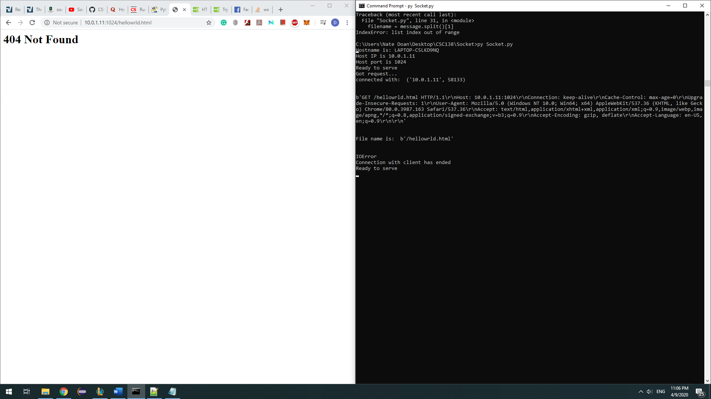

Successful retrieving the html file